Housing First For Youth Vs. Housing First: What's the Difference?

Lindsay McRae Senior Communications Officer, Canadian Observatory on Homelessness
November 23, 2021
Housing First For Youth (HF4Y) vs. Housing First (HF): What's the difference? And does it really matter? We're glad you’re curious — because there are differences, and you guessed it, they really do matter. Although these two program models share a similar name and are based on the same philosophy, one program model is specifically designed for youth, and the other is not.
And in this blog, we'll explain:
- Why a youth-specific HF program model is needed
- How a youth focus makes HF4Y and Housing First different in practice
If you're a program manager, executive director or staff operating a HF4Y model, or if you work in the youth homelessness or housing space, this blog is for you. This blog is also an important read for government officials or funders interested in investing in H4FY programs.

Why is a Youth-Specific Housing First Program Model Needed?
To understand the differences between HF4Y and HF, it’s important to understand why a youth-focused program is needed in the first place. Can't we use a one-size-fits-all approach and call it a day? The answer — as I’m sure you’ve guessed by now — no, not really.
Although HF is one of the few homelessness interventions with an established evidence base and substantiated evidence of its effectiveness with adult populations, the results are less certain when it comes to young people. This is because HF was designed with adults — not youth — in mind. And although HF programs do take on youth clients, the program model was not designed to account for the different developmental and life stages that exist between adults and youth. And herein lies the problem. Unlike adults, young people often lack the experience to live independently or make important life decisions without the support of a trusted and caring adult. And so supports need to be modified to account for this reality.
Imagine for a moment, you are a young person who, for the first time, finds themselves with no place to go:
“If I go to someone for help, will they send me to child protection services?
“Will they force me to live in a group home because I’m a minor?”
“If I do find housing, how do I pay rent? How do I get cable and internet at my place?”
“How do I budget for things like groceries? How do I cook for myself?”
“Who can I trust for advice?”
These are questions you’ve not ever before had to answer. Prior to this, you’ve been living with adults who largely took care of your basic needs. And on top of these questions, you’re also navigating the cognitive and hormonal changes of teenage life. You may also be juggling school, a part-time job, trying to stay connected to your peers.
What you need is support from someone who understands the unique needs of a developing adolescent still learning how to navigate the adult world. You need a program that has the infrastructure to connect you to the appropriate supports and services based on the evidence on what youth experiencing or at risk of homelessness need to live thriving lives. And this is where HF4Y comes in.

How Are HF4Y and HF Different in Practice?

Put simply, HF4Y is specifically designed for youth and focuses on prevention and rapid intervention while HF prioritizes long-term street homelessness (chronic homelessness) and a predominately adult population. Unlike HF, the HF4Y program model and implementation practices were designed entirely around developing adolescents' physical, cognitive, emotional, and social needs. Adult-focused housing programs that choose to take on youth clients — like HF — often overemphasize “independence” at the expense of providing the necessary supports to assist young people in successfully transitioning to adulthood.

The Three Major Differences Between HF & HF4Y
In order to provide youth with the necessary supports to transition into adulthood, HF4Y differs from HF in three key ways:
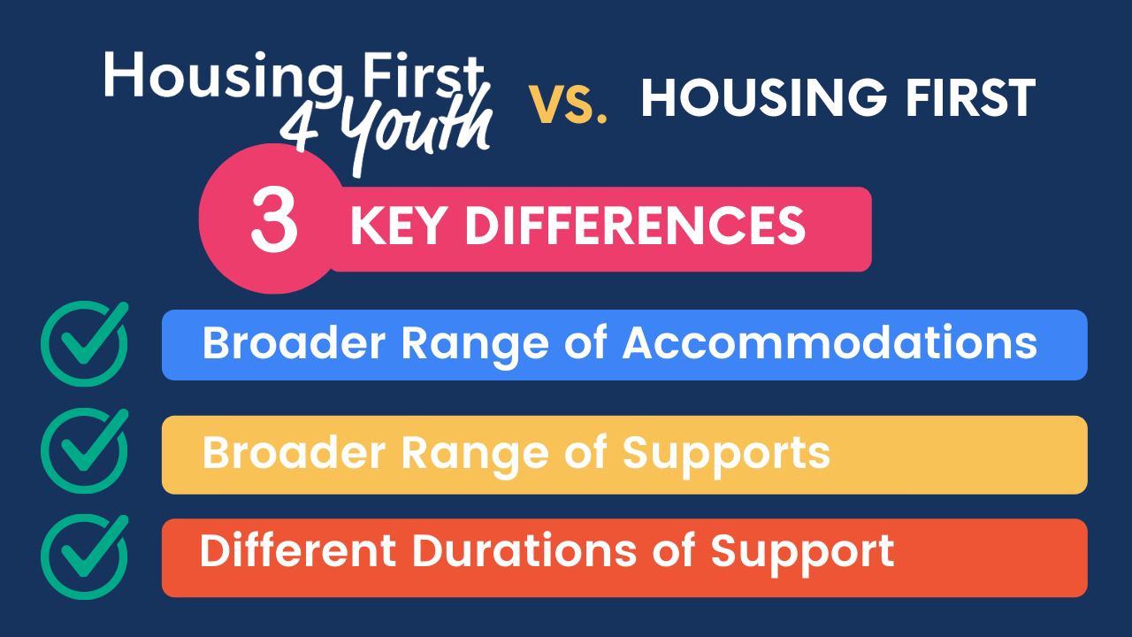

In this next section, we’ll explain these differences in a little more detail.

HF4Y Offers a Broader of Accommodations than HF
While HF programs typically prioritize independent living through the use of scattered-site housing, HF4Y recognizes that youth may not yet have the life skills necessary for independent living or the desire to live alone. While independent living is of course a desired outcome of HF4Y, the developmental needs of young people and local rental laws must be taken into consideration. For example, some jurisdictions do not allow landlords to rent to minors.
Unlike HF, HF4Y accounts for the possibility that youth (more so than adults) may want to return to their family home (through family reconnection). They may also want to first enter into transitional housing. Many young people prefer congregate living models with higher levels of supports in their early years before they are ready to go out on their own. For youth who are ready for independent living in a scattered site/market rent housing, HF4Y can accommodate this as well.
HF4Y recognizes that young people will likely desire a move from one home to another as they progress through the stages of their life, and the program model includes flexibility to ensure that HF4Y support sticks with youth, even if they change tenancies. And for youth who no longer need a HF4Y program, the model allows youth to remain in their housing — they are not required to move once they exit the program.
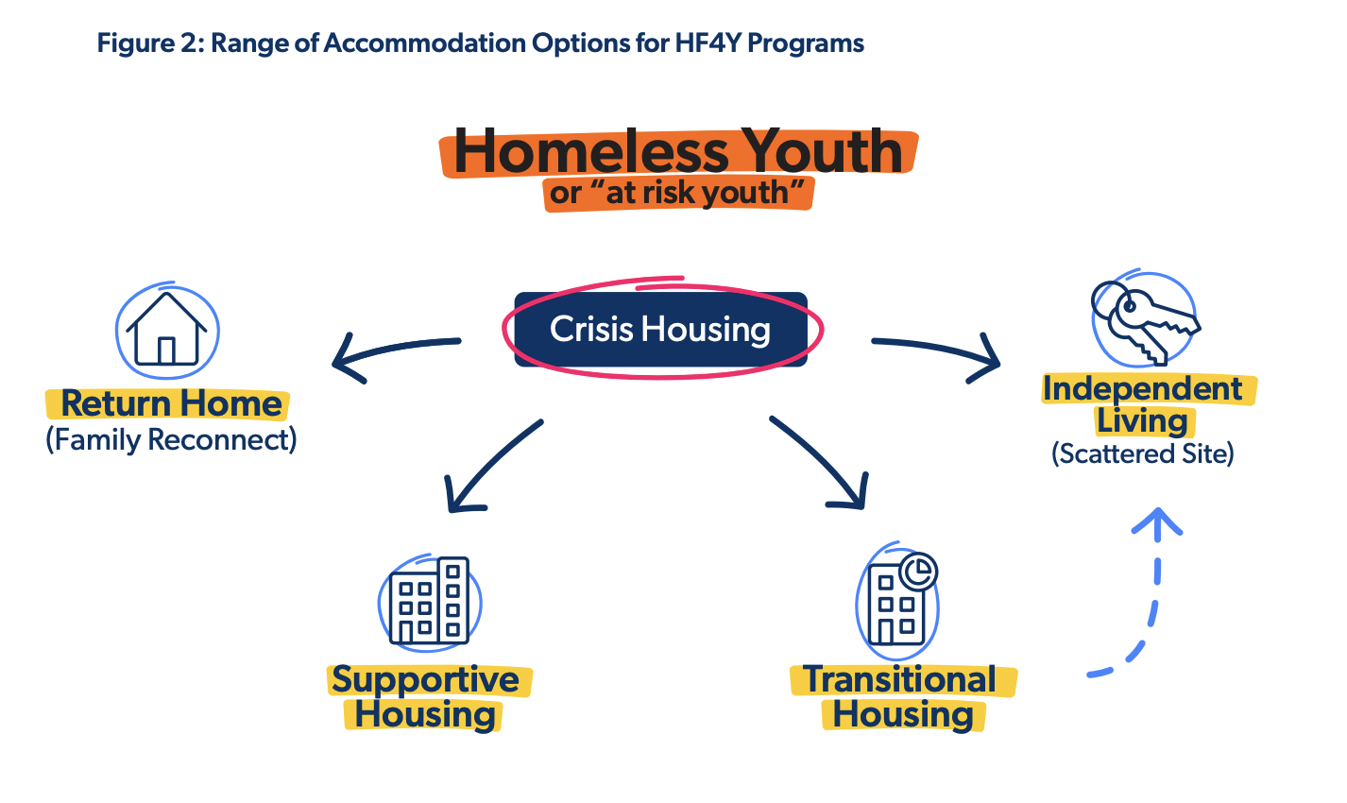

HF4Y Offers a Broader Range of Supports than HF Broader
The HF4Y model offers a much broader range of supports than is typically associated with the adult-focused HF model. Caseloads in HF4Y programs must be kept light (they must not exceed 10) so that caseworkers have the capacity to provide the robust supports that youth need. Youth almost always need much more intensive supports, “hand-holding” and guidance when making life decisions than their adult counterparts. So, unlike HF, HF4Y creates the time and space to help youth achieve levels of self-sufficiency associated with adulthood and facilitate successful transitions to independence. For example, young people may need help with finding housing, managing bills, coordinating their healthcare, finding a job, and navigating the social welfare system.
Additionally, the HF4Y program model dedicates entire categories of support to the aspects of life that youth tend to struggle with more than adults — “Access to Income and Education” and “Social Inclusion”. Youth often have different desires to stay connected or to reconnect with schooling and family members than their adult counterparts. So, youth often require support connecting to schools, postsecondary institutions, employers or training agencies. Furthermore, HF4Y case managers are required to connect them to “natural support networks” that will support them long after they are exited from a HF4Y program. For example: HF4Y workers actively seek out and engage with members of youth’s family.
Lastly, HF4Y offers a longer duration of supports than HF. HF programs often provide time-limited investment in supports, ranging from one to three years, while HF4Y offers individualized, client-driven supports with no time limit. Young people cannot be rushed to assume the responsibilities of an independent adult, and supports must be made available for as long as it takes for the young person to develop the skills, confidence, and financial stability necessary to achieve independence. The focus of HF4Y is not merely a successful transition to independent living, but on supporting a healthy transition to adulthood.
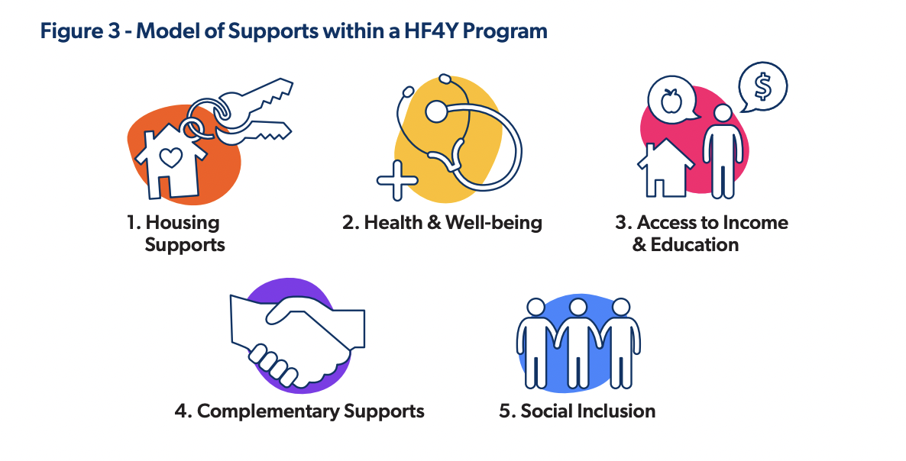

HF4Y Has a Bigger Focus on Prevention than HF
While HF prioritizes chronic homelessness, HF4Y prioritizes prevention. HF programs are designed for people who have experienced homelessness for a significant period of time or who are chronically homeless. But with HF4Y, there's a strong focus on preventing youth from becoming homeless in the first place — and if they do, rapidly intervening to provide them housing and provide them with opportunities to develop skills needed for independent living. Note: This also includes rapidly intervening to support young people already experiencing homelessness.

Key Takeaways
- HF4Y is a youth-focused adaptation of HF — they share the same philosophy and similar principles but are not the same in practice
- HF4Y dedicates entire categories of support to the aspects of life that youth tend to struggle with more than adults — ie:/ connection to education and engaging family and natural supports
- HF4Y is for youth and prioritizes prevention and rapid-rehousing, while HF predominantly serves adults and prioritizes chronic homelessness
- HF4Y offers a range of age-appropriate housing options that meet youth where they're at in their journey towards independent living and adulthood.
- HF4Y model offers a much broader range of supports than is typically associated with the adult-focused HF model
- The caseload size for HF4Y does not exceed 10 and there are no time limits on housing and supports
After reading this blog, we hope that you have a better understanding of why we can't simply drop young people into adult housing, provide them with supports designed for adults, and expect them to be well and remain stably housed. For HF to work for youth, a program model that explicitly takes into account their age-specific needs is necessary. And that's where HF4Y comes in. Although HF4Y draws from the same philosophy of HF, the two models differ in the age group their supports were designed to accommodate. Unlike HF, HF4Y is a program model entirely designed to meet youth at their developmental stage — a model that recognizes youth as distinct from adults and supports them accordingly.
HF4Y is a living, breathing program model that we continue to modify as we support more and more youth and hear their insights about what works well, and what could use adjusting. As it stands now, HF4Y is a reflection of the most up-to-date research and insights from communities about the types of housing and supports needed to prevent and end youth homelessness.

